CREATE REGISTRATION INTERFACE

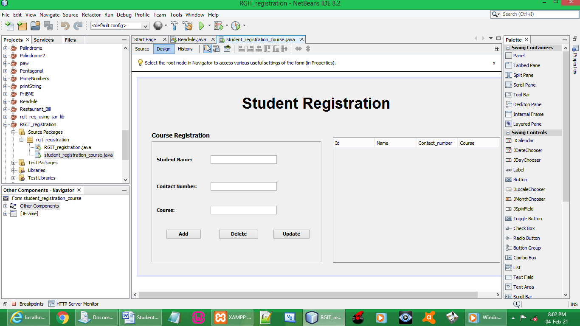

CODES:

import java.sql.Connection;
import java.sql.DriverManager;
import java.sql.PreparedStatement;
import java.sql.ResultSet;
import java.sql.ResultSetMetaData;
import java.sql.SQLException;
import java.util.Vector;
import java.util.logging.Level;
import java.util.logging.Logger;
import javax.swing.JOptionPane;
import javax.swing.table.DefaultTableModel;

public student_registration_course() {
initComponents();
table_update(); // to make jtable details appear from database
}

Connection myCon;
PreparedStatement myPs;

BUTTON ADD:

// Storing entered input by user
String name = txtName.getText();
String mobile = txtContactNumber.getText();
String course = txtCourse.getText();

try {

myCon = (Connection) DriverManager.getConnection(
"jdbc:mysql://localhost:3306/rgit?zeroDateTimeBehavior=convertToNull", "root" , "");

myPs = myCon.prepareStatement("insert into ict(name, mobile, course) values(?,?,?)");
myPs.setString(1, name);
myPs.setString(2, mobile);
myPs.setString(3, course);
myPs.executeUpdate();

JOptionPane.showMessageDialog(this, "Add Completed");

table_update();

txtName.setText("");
txtContactNumber.setText("");
txtCourse.setText("");

} catch (Exception e){
e.printStackTrace();
}

BUTTON DELETE

DefaultTableModel df = (DefaultTableModel)jTable1.getModel();
int selectedIndex = jTable1.getSelectedRow();

try {

int id = Integer.parseInt(df.getValueAt(selectedIndex, 0).toString());

int dialogResult = JOptionPane.showConfirmDialog(null,
"Are you sure you want to delete the data?", "Warning",JOptionPane.YES_NO_OPTION);

if (dialogResult == JOptionPane.YES_OPTION){

String name = txtName.getText();
String mobile = txtContactNumber.getText();
String course = txtCourse.getText();

myCon = DriverManager.getConnection(
"jdbc:mysql://localhost:3306/rgit?zeroDateTimeBehavior=convertToNull","root","");

myPs = myCon.prepareStatement("delete from ict where id = ?");
myPs.setInt(1, id);

myPs.executeUpdate();

JOptionPane.showMessageDialog(this, "Delete Completed");

table_update();

txtName.setText("");
txtContactNumber.setText("");
txtCourse.setText("");

}
} catch (SQLException ex) {
Logger.getLogger(student_registration_course.class.getName()).log(Level.SEVERE, null, ex);
}

BUTTON UPDATE

DefaultTableModel df = (DefaultTableModel)jTable1.getModel();
int selectedIndex = jTable1.getSelectedRow();

try {

int id = Integer.parseInt(df.getValueAt(selectedIndex, 0).toString());
String name = txtName.getText();
String mobile = txtContactNumber.getText();
String course = txtCourse.getText();

myCon = DriverManager.getConnection(
"jdbc:mysql://localhost:3306/rgit?zeroDateTimeBehavior=convertToNull","root","");

myPs = myCon.prepareStatement("update ict set name = ?, mobile = ?, course = ? where id = ?");
myPs.setString(1, name);
myPs.setString(2, mobile);
myPs.setString(3, course);
myPs.setInt(4, id);
myPs.executeUpdate();

JOptionPane.showMessageDialog(this, "Update Completed");

table_update();

txtName.setText("");
txtContactNumber.setText("");
txtCourse.setText("");

} catch (SQLException ex) {
Logger.getLogger(student_registration_course.class.getName()).log(Level.SEVERE, null, ex);
}

JTABLE FUNCTION (data at database to appear on Jtable):
private void table_update(){

int x;

try {

myCon = (Connection) DriverManager.getConnection(
"jdbc:mysql://localhost:3306/rgit?zeroDateTimeBehavior=convertToNull", "root" , "");

myPs = myCon.prepareStatement("select * from ict");
ResultSet rs = myPs.executeQuery();
ResultSetMetaData rss = rs.getMetaData();
x = rss.getColumnCount();

DefaultTableModel df = (DefaultTableModel)jTable1.getModel();
df.setRowCount(0);

while(rs.next()){
Vector v = new Vector();

for(int a = 1; a <= x; a++){
v.add(rs.getString("id"));
v.add(rs.getString("name"));
v.add(rs.getString("mobile"));
v.add(rs.getString("course"));
}

df.addRow(v);
}
} catch (SQLException ex) {
Logger.getLogger(student_registration_course.class.getName()).log(Level.SEVERE, null, ex);
}

JTABLE FUNTION (event, mouse, mouseClick):

DefaultTableModel df = (DefaultTableModel)jTable1.getModel();
int selectedIndex = jTable1.getSelectedRow();

txtName.setText(df.getValueAt(selectedIndex, 1).toString());
txtContactNumber.setText(df.getValueAt(selectedIndex, 2).toString());
txtCourse.setText(df.getValueAt(selectedIndex, 3).toString());

OUTPUT:

RUN STUDENT REGISTRATION

ADD DETAILS

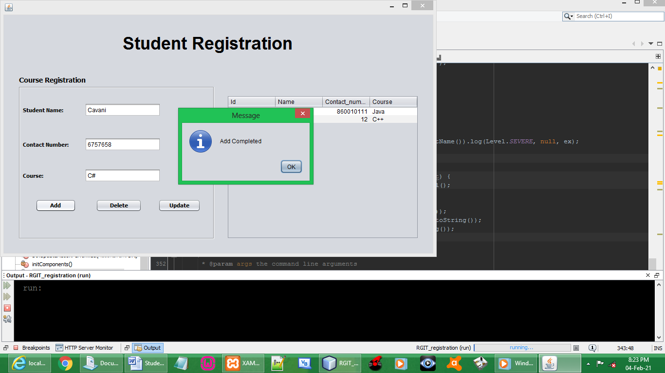

THE ADDED DETAILS

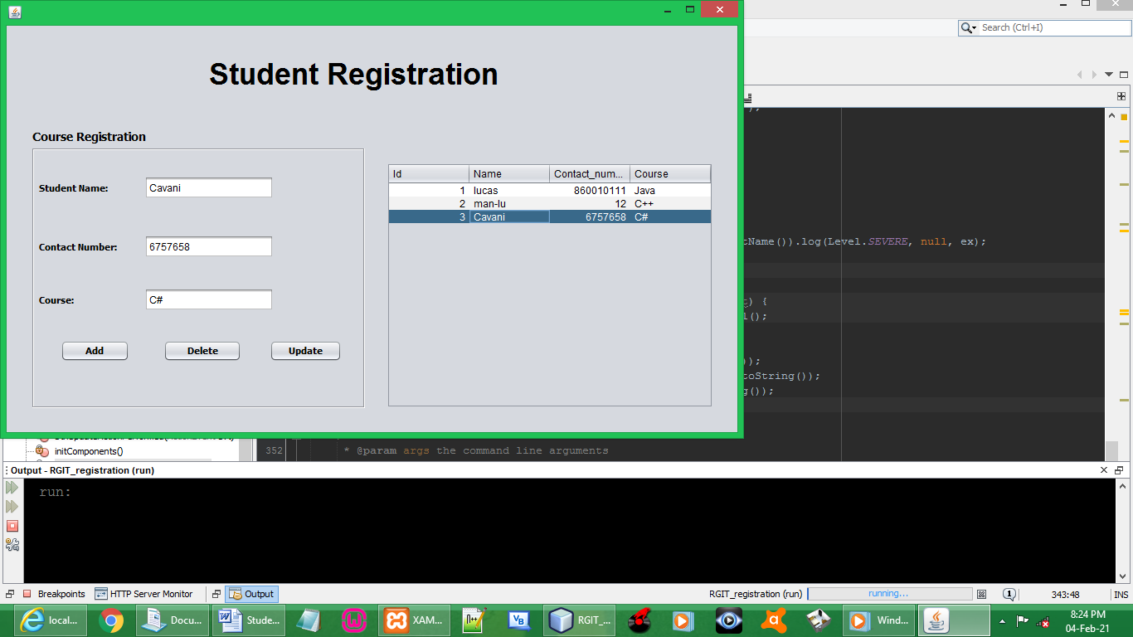

UPDATE THE DETAILS

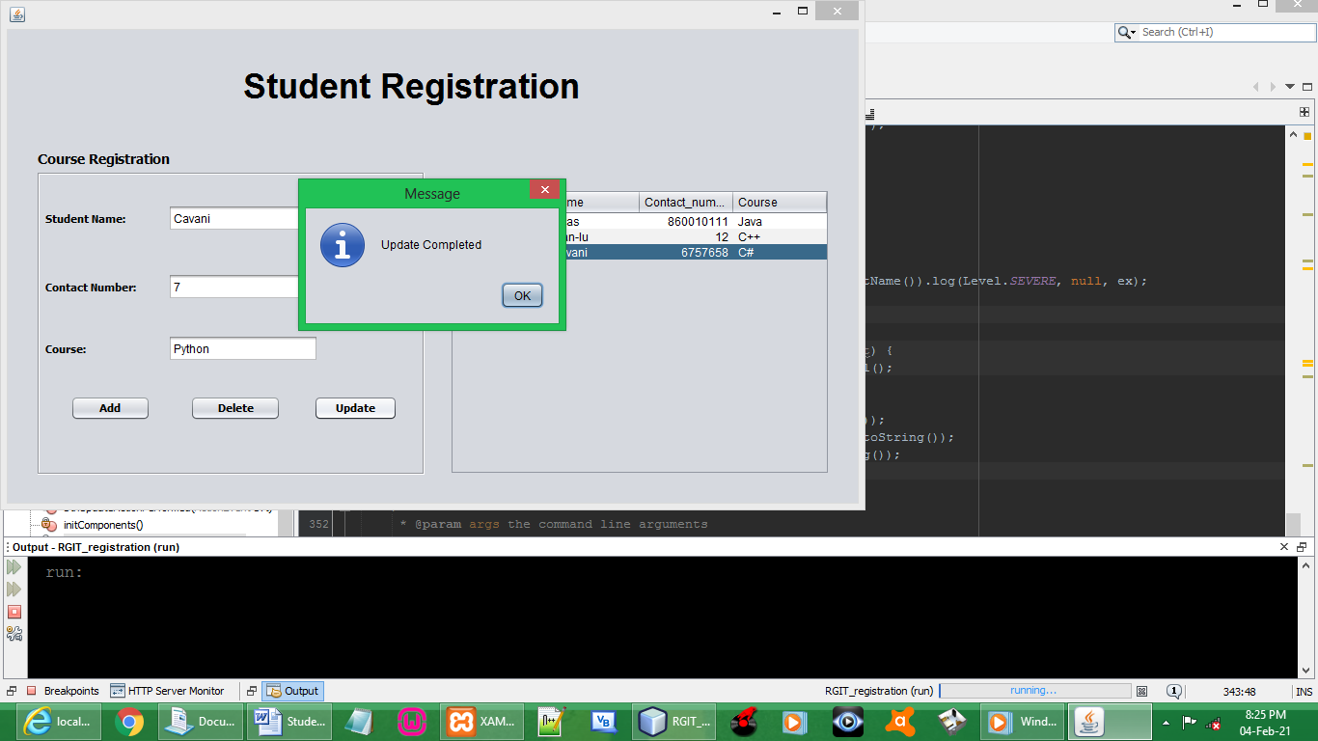

THE UPDATED DETAILS

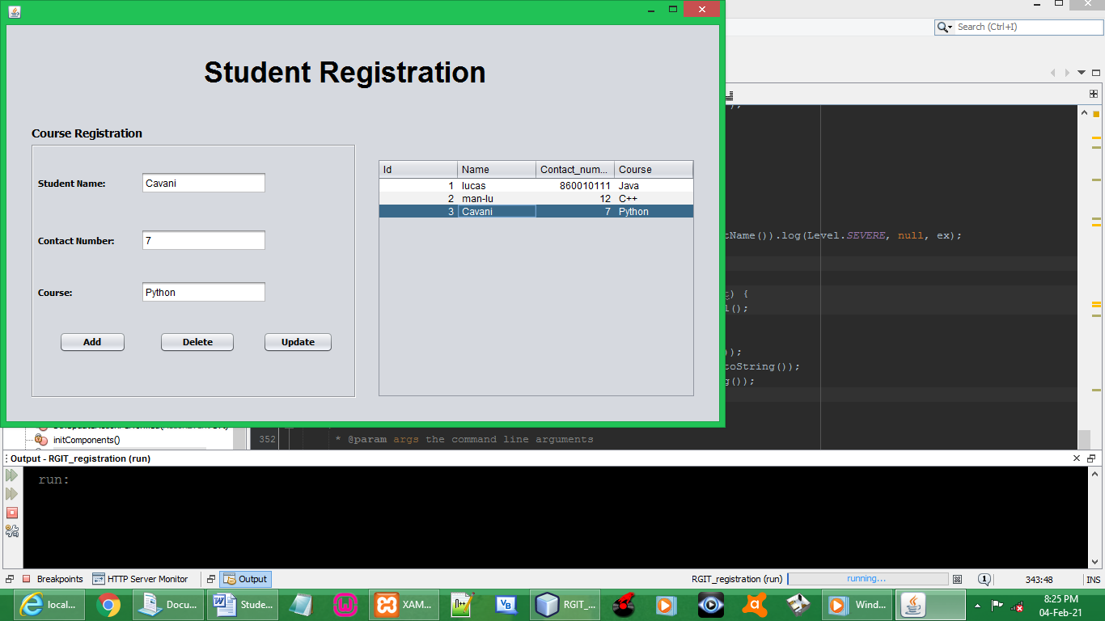

DELETE THE ADDED DETAILS

